1.On week4, able to describe and apply agile methods and will have the opportunity to better understand best fit methods for real-life scenarios .

We had completed Represent network diagrams as Gantt charts..

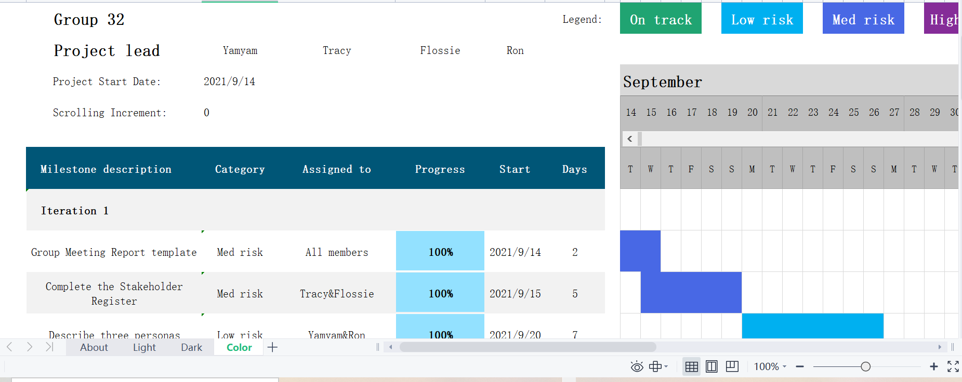

Yam Yam and Ron are responsible for Milestone description and Category .

Tracy and Flossie are responsible for summarizing the start and days.

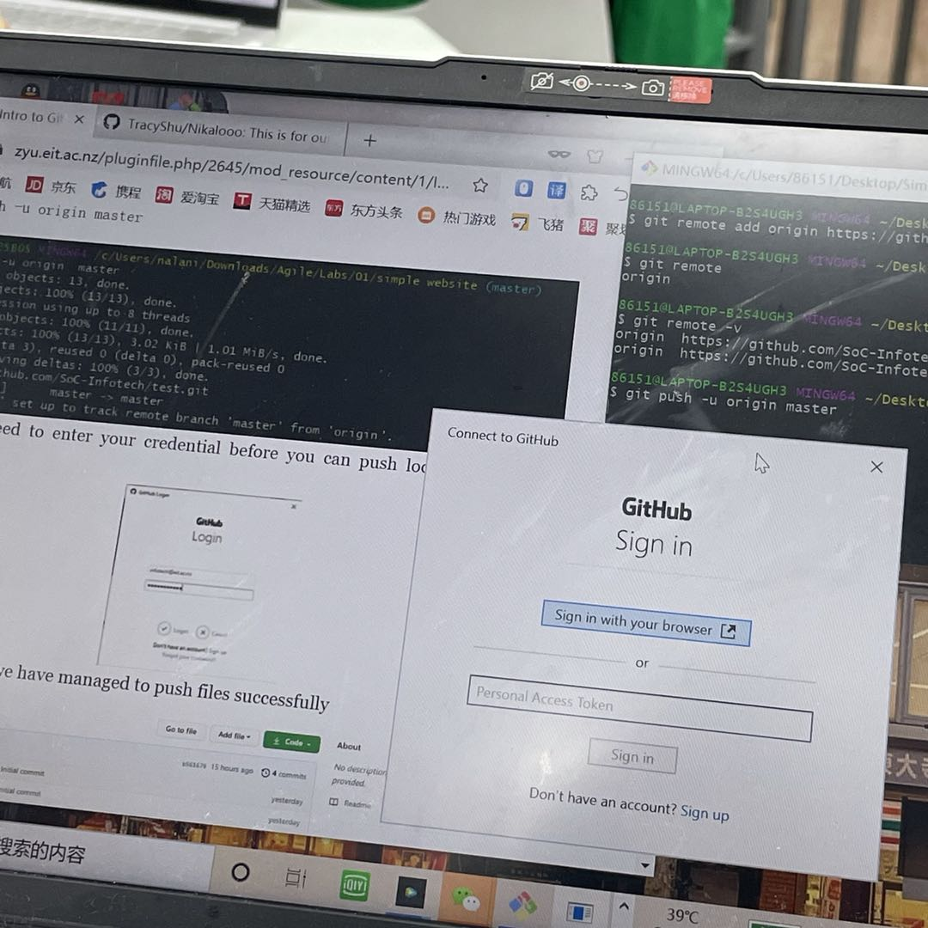And we continue work on Practical Project - Iteration 2 and complete Lab 4 - GitHub.

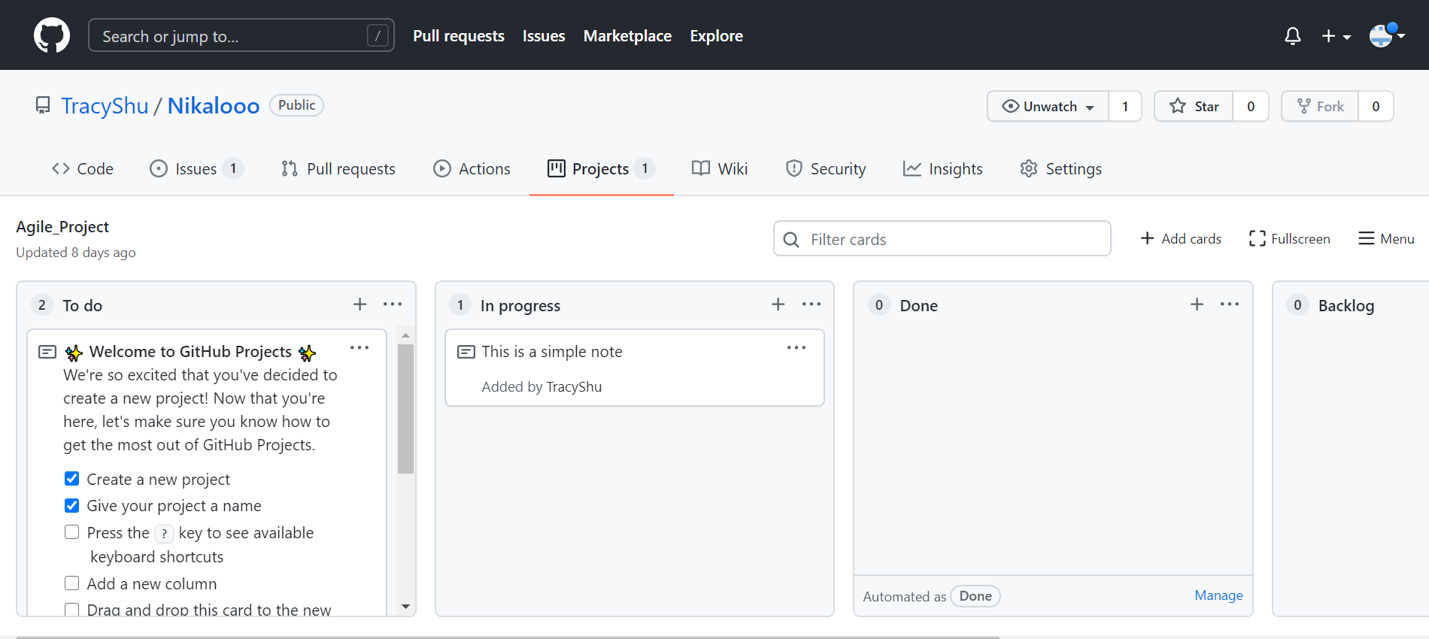

On week5,we were able to describe and apply best practices for project documentation.

Complete Lab 5 - GitHub.

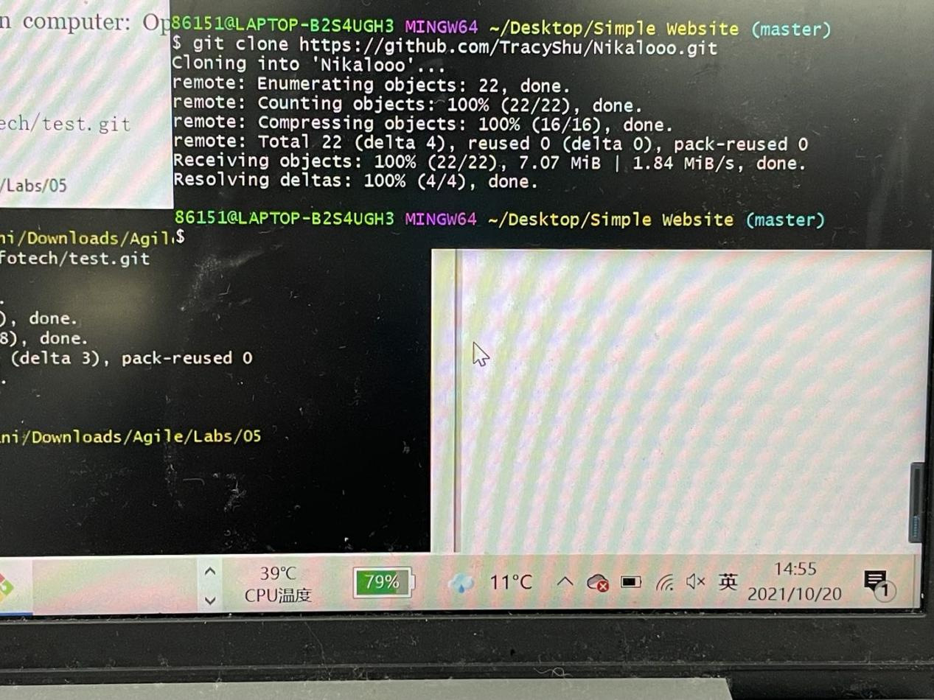

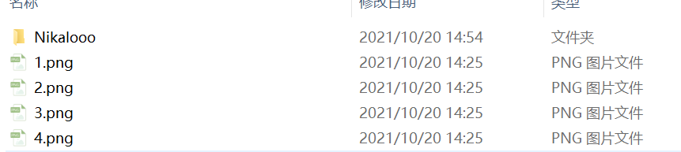

Tracy and Flossie worked on comparing between plain text and markup language.

Yam Yam and Ron worked on Identifying the main purpose of project documentation.

We are working together to Start work on Practical Project - Iteration 3.

2.Provide feedback about what’s working, what’s not working, and what your group needs to improve on as you prepare for Iteration 2.

It is efficient to use network diagrams and the Critical Path Method to calculate task and project completion times and we we explored the most popular techniques used for planning, estimation, and scheduling.

But we have some problems on use source code comments.

We can get the gist of github, but some usage is not so clear.